**TASK 4: OLAP Operations (using Redshift or PostgreSQL):**

Perform OLAP operations (Drill Down, Rollup, Cube, Slice, and Dice) on the "sales_sample" table to analyze sales data. The project will include the following tasks:

**1. Database Creation**

Create a database to store the sales data (Redshift or PostgreSQL).

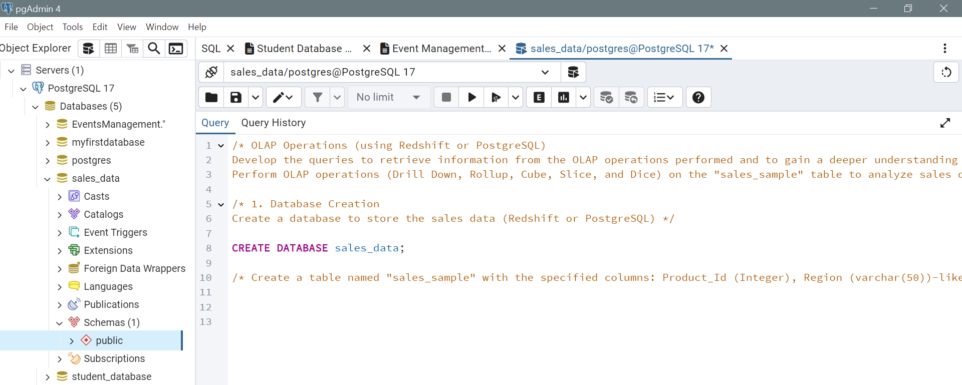

Create a table named "sales_sample" with the specified columns: Product_Id (Integer) , Region (varchar(50))-like East ,West etc, Date (Date) , Sales_Amount (int/numeric) ,

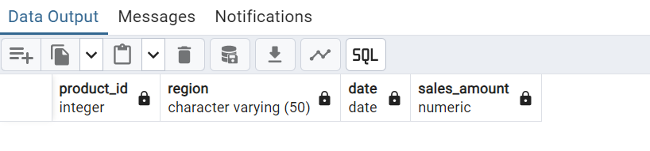

**2. Data Creation**

Insert 10 sample records into the "sales_sample" table, representing sales data.

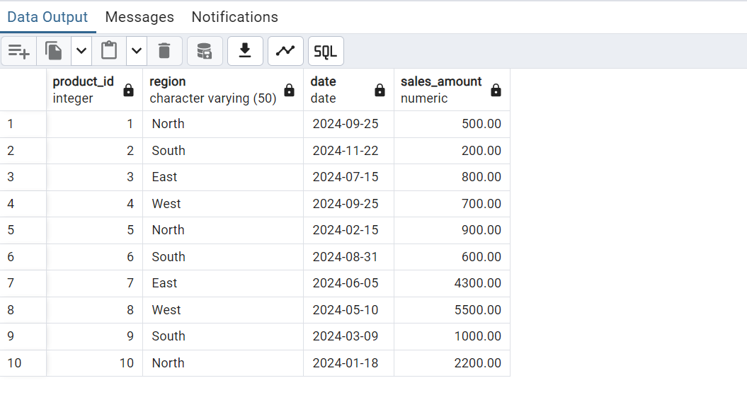

**3. Perform OLAP operations**

a) Drill Down-Analyze sales data at a more detailed level. Write a query to perform drill down from region to product level to understand sales performance.

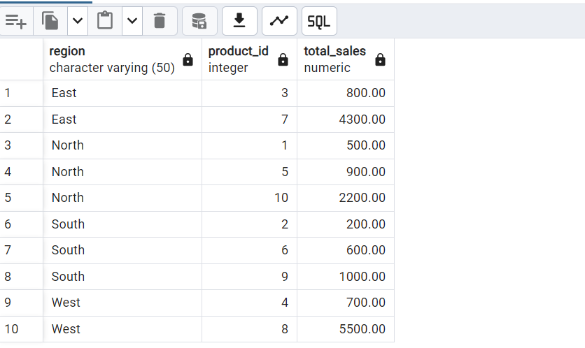

b) Rollup- To summarize sales data at different levels of granularity. Write a query to perform roll up from product to region level to view total sales by region.

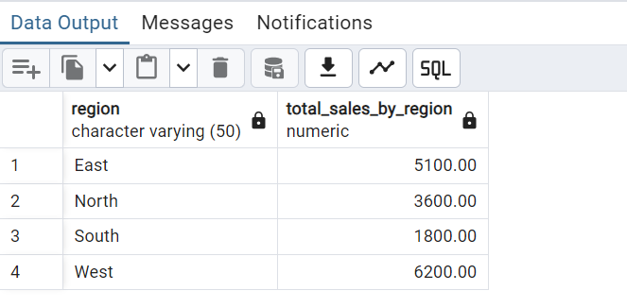

c) Cube - To analyze sales data from multiple dimensions simultaneously. Write a query to Explore sales data from different perspectives, such as product, region, and date.

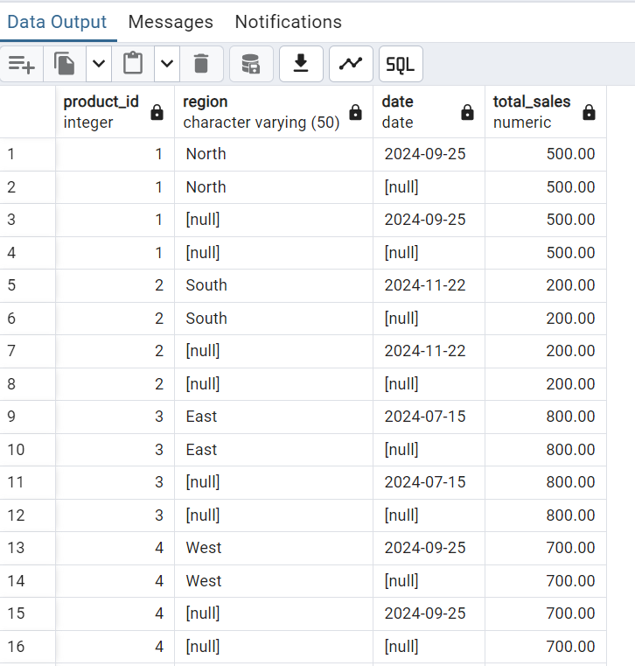

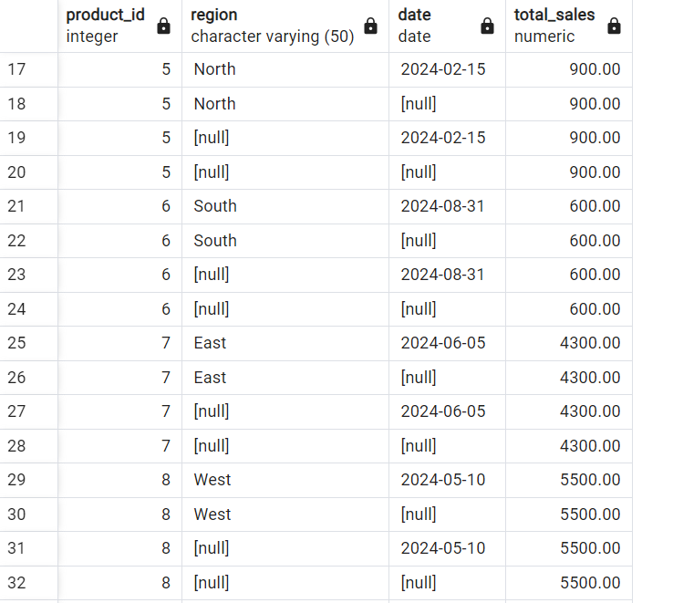

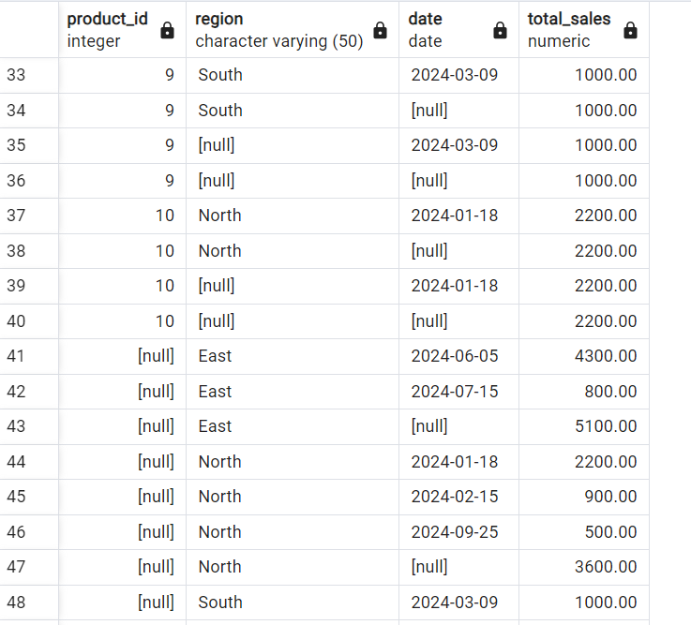

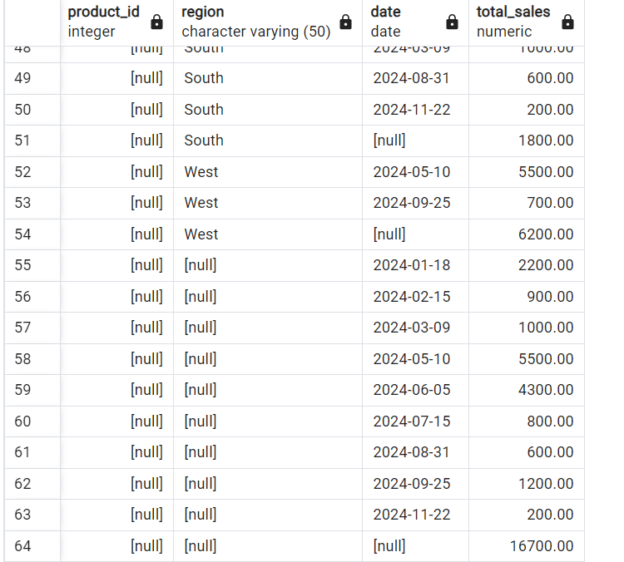

d) Slice- To extract a subset of data based on specific criteria. Write a query to slice the data to view sales for a particular region or date range.

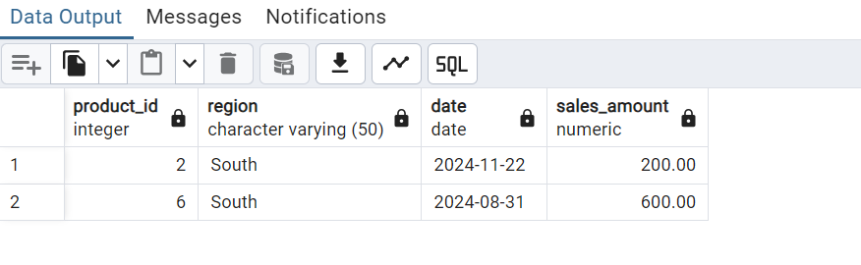

e) Dice - To extract data based on multiple criteria. Write a query to view sales for specific combinations of product, region, and date

